Daily Defence Current Affairs
10 May 2024

Vice Admiral Sanjay Bhalla New Chief of Personnel of Indian Navy
- Vice Admiral Sanjay Bhalla assumes charge as the Chief of Personnel of the Indian Navy, on 10 May 24. He was commissioned in the Indian Navy on 01 Jan 1989. In a career spanning 35 years, he has held a number of specialist, staff and operational appointments, both afloat and ashore.
- After completing his Specialisation Course in Communication and Electronic Warfare, he served as a specialist onboard several frontline warships. He subsequently had the privilege of holding challenging, fulfilling and eventful Commands at sea, which include, INS Nishank, INS Taragiri, INS Beas and the coveted appointment of Flag Officer Commanding Eastern Fleet (FOCEF).
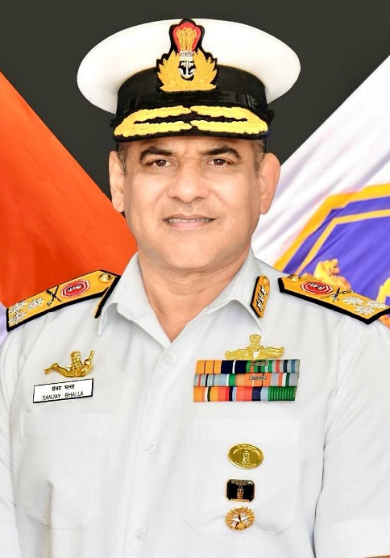

ICG signs MoU For Manufacturing & Supply Of Indigenous Marine-grade Aluminium
- ICG and Hindalco Industries, on May 09, 2024, inked a MoU in New Delhi for the manufacturing and supply of indigenous marine-grade aluminium to Indian public and private shipyards for the construction of ships. The MoU will also provide benefits such as quarterly pricing, priority in supplies and Turnover discount.
- The ICG fleet is presently operating 67 ships with aluminium hulls with capability of operating in shallow waters. To further boost coastal security, it has planned to induct more such vessels where the indigenously manufactured marine-grade aluminium will be utilised.
- Hindalco Industries Limited an Indian aluminium and copper manufacturing company is a subsidiary of the Aditya Birla Group.[5] Its headquarters are at Mumbai, Maharashtra, India.
- The company is listed in Forbes Global 2000 (2023) at 661st rank. Its market capitalization by the end of November 2023 was US$15.6 billion.
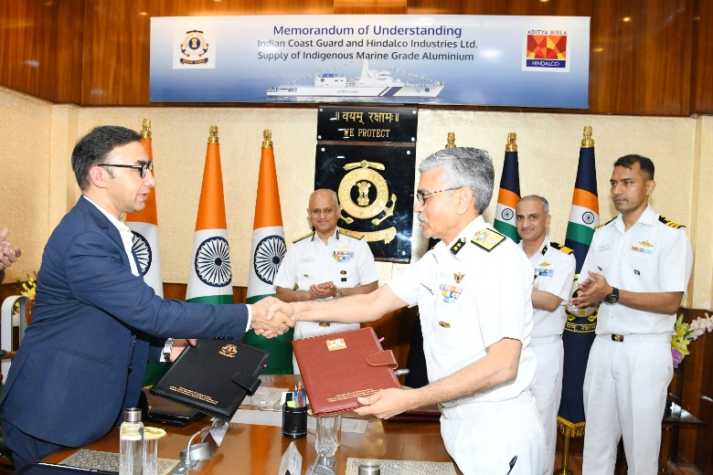
Inter-Services Organisations (Command, Control & Discipline) Act Notified
- The Inter-Services Organisations (Command, Control and Discipline) Act has been notified through a Gazette Notification to be enforced with effect from May 10, 2024.
- In order to bolster effective command, control and efficient functioning of ISOs the bill was passed by both the Houses of Parliament during the Monsoon Session of 2023. The Bill received the assent of the President on August 15, 2023.
- The Act empowers Commanders-in-Chief and Officers-in-Command of ISOs to exercise control over Service personnel, serving under them, for effective maintenance of discipline and administration, without disturbing the unique service conditions of each individual Service.
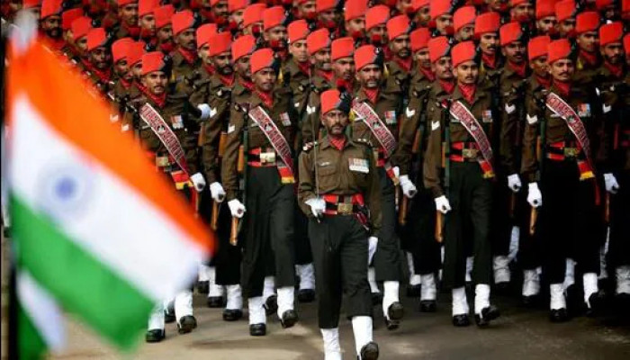
Keel Laying of 8th ASW SWC (ex-GRSE)
      - Keel laying ceremony of the 8th ASW SWC (ex-GRSE) was held at M/s GRSE, Kolkata on 10 May 24. The contract for indigenous design and construction of 08 x ASW SWC ships was concluded on 29 Apr 19 between MOD and M/s GRSE, Kolkata.
      - As on date six ships of the project have already been launched with delivery of first ship (Arnala) planned in Aug 24.
      - Arnala Class of ship will replace the in-service Abhay class ASW Corvettes of Indian Navy and are designed to undertake anti-submarine operations in coastal waters, Low Intensity Maritime Operations (LIMO) and Mine Laying Operations
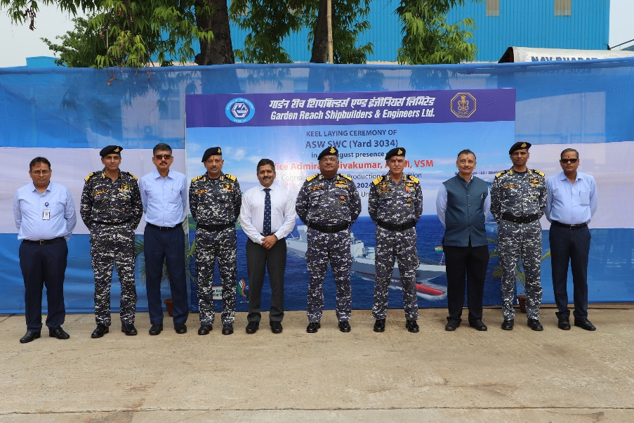
DRDO Organises 8th Technology Council Meeting
DRDO organised the 8th Technology Council Meeting in New Delhi on May 09, 2024. The meeting was held to review the status of induction of DRDO technologies into the CAPFs Police and National Disaster Response Force under the Ministry of Home Affairs (MHA).
Various DRDO laboratories from across the country participated in the meeting virtually. The meeting had active participation and was successful in consolidating the progress achieved. It also laid out a roadmap of activities for the next six months.
DRDO is the premier research organisation involved in development of critical and futuristic technologies for the Defence Services towards achieving self-reliance.
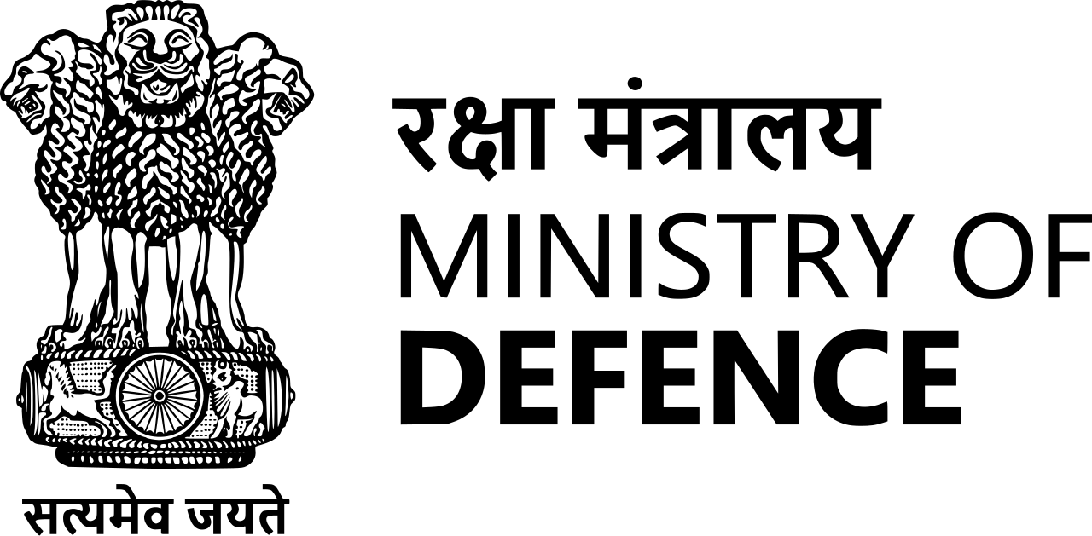

REVIEW QUESTIONS

- Who chaired the "Parivartan Chintan II" event?
- Prime Minister Narendra Modi
- Chief of Defence Staff Gen Anil Chauhan
- Defence Minister Rajnath Singh
- Former President Ram Nath Kovind
ANSWER: B

- When is National Technology Day celebrated?
- May 10
- May 11
- April 11
- June 11
ANSWER: B

- Which organization signed a MoU with JSP for the supply of indigenous marine grade steel?
- Indian Navy
- Indian Army
- Indian Coast Guard (ICG)
- Ordnance Factory Medak
ANSWER: D

- Where was the keel laying ceremony of the 8th ASW SWC held?
- New Delhi
- Kolkata
- Mumbai
- Chennai
ANSWER: B

- Who assumed charge as the Chief of Personnel of the Indian Navy?
- Vice Admiral Sanjay Bhalla
- Rear Admiral Manoj Kumar
- Vice Admiral Krishna Swaminathan
- Rear Admiral Rajesh Dhankhar
ANSWER: A

- Which organization signed a MoU with ICG for the supply of indigenous marine-grade aluminium?
- Tata Steel
- Hindalco Industries
- Reliance Industries
- JSW Steel
ANSWER: B

- Deesa Airbase Of IAF Is Located In Which District Of Gujrat?
- Surat
- Banaskantha
- Vapi
- None
ANSWER: B

- __ Is The Largest Air Command Of The IAF?
- Eastern
- Western
- Southern
- Northern
ANSWER: B

- Indian Navy Sailing Championship 2022 Was Organised By
- IMA
- SNC
- INA
- NDA
ANSWER: C

- Kamikaze Drones Developed By
- India
- Russia
- Ukraine
- Iran
ANSWER: B

- Tapas-BH Stands For
- Tactical Airborne Platform for Advanced Surveillance- Beyond Horizon
- Tactical Airborne Platform for Aerial Surveillance- Beyond Horizon
- Tactical Airborne Prime for Aerial Surveillance- Beyond Horizon
- None
ANSWER: B

- Which Indian Navy Ship Participated In IBSAMAR Exercise?
- INS Utkrosh
- INS Kochi
- INS Tarkash
- None of the above
ANSWER: C

- Newly Created ‘Weapon System Branch’ Is Made Up For
- IAF
- BSF
- Indian Army
- ICG
ANSWER: A

- M777 Ultra-Light Howitzer Have A Range Of Up To
- 20 km
- 25 km
- 30 km
- None of the above
ANSWER: C

- Recently QRSAM Missile Was Tested By
- Indian Navy & ISRO
- Indian Army & ISRO
- Indian Army & DRDO
- ICG & ISRO
ANSWER: C

- Bogota Is The Capital Of
- BAHRAIN
- BANGLADESH
- BARBADOS
- Colombia
ANSWER: D

- “Lal Salam" Book Written By
- Smriti Irani
- JK Rowling
- Jhumpa Lahiri
- Amitav Ghosh
ANSWER: A

- Vajra Prahar Exercise Conducted B/W Bharat And?
- USA
- UK
- Israel
- Qatar
ANSWER: A

- VL-SRSAM Developed By
- ISRO
- DRDO
- NASA
- JAXA
ANSWER: B

- Hq Of The MOD Is In
- Mumbai
- New Delhi
- Chennai
- Bengaluru
ANSWER: B

